**DURA CRIB™ BRAND PRODUCTS**

**WORKING LOAD GUIDE**

**July 9, 2025**

**PLEASE POST THIS MANUAL IN A conspicuous AREA WHERE PRODUCTS ARE BEING USED.**

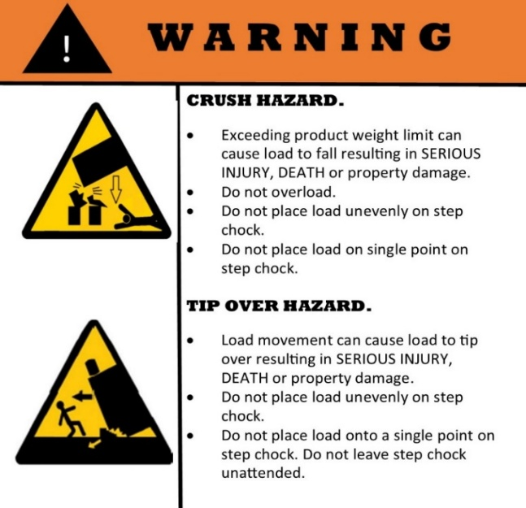

**Step Chocks**

Thank you for your purchase of our products and for supporting products made from recycled plastic in the USA. We welcome your comments and feedback.

Please note these products may have been shipped to you with your distributor's name or distributor's part number on the product identification tag. If you do not have a genuine Turtle Plastics product tag on your product or if you have any questions regarding our products, please contact us at:

Turtle Plastics®

7400 Industrial Parkway Drive

Lorain, OH 44053

1-800-756-6635

info@turtleplastics.com

|  |  |  |  |  |  |  |  |  |  |
| --- | --- | --- | --- | --- | --- | --- | --- | --- | --- |
| **Product Photo** | |  | |  | |  | |  | |
| **Capacity** | | **Heavy Duty** | | **Heavy Duty** | | **Heavy Duty** | | **Heavy Duty** | |
| **Mfg. Part #** | | **S612-24** | | **S612-12** | | **66SC-36** | | **67HDC-30** | |
| **Product Name** | | **The Slab®** | | **Half Slab®** | | **Super Crib XL®  Platform Base Crib** | | **Black Diamond Crib®** | |
| **Working Load Limit (KG/LBS) @ 25C/ 77F** | | **110,000/242,508** | | **55,000/121,254** | | **78,400/172,842** | | **71,600/157,850** | |
| **Dimensions/ Weight** | | **24"x12”x6”   23.12kg/51lbs** | | **12"x12"x6” 11.79kg/26lbs** | | **36”x6"x6" 14.52kg/32lbs** | | **30"x7”x6” 18.6kg/41lbs** | |
| **Product Photo** | |  | |  | |  | |  | |
| **Capacity** | | **Heavy Duty** | | **Heavy Duty** | | **Heavy Duty** | | **Medium Duty** | |
| **Mfg. Part #** | | **44HDC-36** | | **67PC-24** | | **44HDC-30** | | **67SC-24** | |
| **Product Name** | | **Super Black Diamond Crib XL™** | | **Prime Crib®** | | **Profile Black Diamond Crib™** | | **Super Crib®** | |
| **Working Load Limit (KG/LBS) @ 25C/ 77F)** | | **69,400/153,000** | | **58,800/129,631** | | **50,800/111,994** | | **49,900/110,000** | |
| **Dimensions/ Weight** | | **36”x4"x4" 8.2kg/19lbs** | | **24"x7”x6” 12.25kg/27lbs** | | **30”x4"x4" 6.8kg/15lbs** | | **24”x7”x6" 11.79kg/26lbs** | |
| **Product Photo** | |  | |  | |  | |  | |
| **Capacity** | | **Medium Duty** | | **Light Duty** | | **Light Duty** | | **Light Duty** | |
| **Mfg. Part #** | | **44HDC-24** | | **44HDC-18** | | **1B, 2B, 3B** | | **67HDC-10** | |
| **Product Name** | | **Super Black Diamond Crib™** | | **Black Diamond Crib-18™** | | **Turtle Lock Block/Blox®** | | **Little Black Diamond Crib®** | |
| **Working Load Limit (KG/LBS) @ 25C/ 77F** | | **40,823/90,000** | | **31,751/70,000** | | **31,000/68,343 per block** | | **23,700/52,249** | |
| **Dimensions/ Weight** | | **24”x4"x4" 5.9kg/13lbs** | | **18”x4”x4”**  **4.54kg/10lbs** | | **9"x9"x1" = 1.36kg/3lbs  9"x9"x2" = 2.27kg/5lbs 9"x9"x3" = 3.18kg/7lbs** | | **10”x7”x6” 5.9kg/13lbs** | |
| **Product Photo** |  | |  | |  | |  | |
| **Capacity** | **Light Duty** | | **Light Duty** | | **Light Duty** | | **Light Duty** | |
| **Mfg. Part #** | **44HDC-12** | | **44PL-18** | | **44-18** | | **24-18** | |
| **Product Name** | **Black Diamond Crib-12™** | | **Hybrid Crib®** | | **44-18 Pyramid Crib™** | | **24-18 Pyramid Crib™** | |
| **Working Load Limit (KG/LBS) @ 25C/ 77F)** | **21,722/48,000** | | **20,500/45,194** | | **13,607/30,000** | | **8,164/18,000** | |
| **Dimensions/ Weight** | **12”x4"x4” 2.72kg/6lbs** | | **A black stone staircase with steps  AI-generated content may be incorrect.18”x4"x4" 2.72kg/6lbs** | | **18”x4"x4” 2.72kg/6lbs** | | **18”x4”x2"  1.36kg/3lbs** | |
| **Product Photo** | **A black stone stairs with a yellow circle around it  AI-generated content may be incorrect.A black stone staircase with a yellow circle around it  AI-generated content may be incorrect.A red helmet on a black background  AI-generated content may be incorrect.A red helmet on a black background  AI-generated content may be incorrect.A black stone stairs with a yellow circle around it  AI-generated content may be incorrect.** | | | |  | |  | |
| **Capacity** | **Light Duty** | | | | **Light Duty** | | **Light Duty** | |
| **Mfg. Part #** | **SC-1 and SC-3 (SC-3 is discontinued)** | | | | **SC-2** | | **SC-COG-1** | |
| **Product Name** | **Standard and Giant Step Chock** | | | | **Medium Step Chock** | | **Cog Step Chock** | |
| **Working Load Limit (KG/LBS) @ 25C/ 77F** | **4,400/9,700** | | | | **4,400/9,700 per chock** | | **1,701/3,750 without cog  or 2,722/6,000 with cog** | |
| **Dimensions/ Weight** | **SC-1 = 24½"x5¾"(base)x 3¾"(w)x10¾”"(h)**  **6.8kg/15lbs**  **SC-3=31½” x11˝(base)x5˝(w) x22˝ (h)** | | | | **29½"x9"(base)x**  **4½"(w)x17¼"(h) 15.88kg/35lbs** | | **24¼"(base) x 6⁵/₈”(w)x10¾”(h) Cog - 9.98kg/22lbs**  **Platform - 2.72kg/6lbs** | |
| **Product Photo** | **A red helmet on a black background  AI-generated content may be incorrect.A black square object with a blue strap  AI-generated content may be incorrect.A black square object with a blue strap  AI-generated content may be incorrect.A black rectangular object with orange cord  Description automatically generated** | | | | **Reference Material (Scan QR code below):**  **A qr code on a white background  AI-generated content may be incorrect.Dura Crib™ Brand Products Safety & Reference Manual**  **A qr code on a white background  AI-generated content may be incorrect.**  **Products Limited Warranty** | | | |
| **Capacity** | **Medium Duty** | | | |
| **Mfg. Part #** | **CTP2424-2 and CTP1818-1.5** | | | |
| **Product Name** | **ModPad® (US Pat. No. D804,768)** | | | |
| **Working Load Limit (KG/LBS)/PSI @ 25C/ 77F** | **54,431/102,058 each pad size** | | | |
| **Dimensions/ Weight** | **24"x24"x2" 17.32kg/38lbs** | | **18"x18"x1½" 7.26kg/16lbs** | |

|  |  |  |  |  |
| --- | --- | --- | --- | --- |
| **Product Photo** |  |  |  |  |
| **Capacity** | **Super Heavy Duty** | **Light Duty** | **Medium Duty** | **Super Heavy Duty** |
| **Mfg. Part #** | **LDP** | **PSP18** | **PSP24** | **PCP24** |
| **Product Name** | **Little Black Diamond Pad** | **Single Hybrid Crib Pad** | **Single Prime/Super Crib Pad** | **Prime Crib Stack Pad** |
| **PSI (KG/LBS) @ 25C/ 77F** | **1,361/3,000** | **1,361/3,000** | **1,361/3,000** | **1,361/3,000** |
| **Dimensions/ Weight** | **10”x7”x2”**  **2.1kg/4.5lbs** | **18"x4”x1”**  **1.37kg/3lbs** | **24"x6”x1”**  **2.27kg/5lbs** | **24"x24”x2”**  **18kg/40lbs** |
| **Product Photo** |  |  |  |  |
| **Capacity** | **Super Heavy Duty** | **Super Heavy Duty** | **Super Heavy Duty** | **Super Heavy Duty** |
| **Mfg. Part #** | **SP12** | **SP12-3** | **SP24** | **SP24-2** |
| **Product Name** | **Half Slab Pad** | **Half Slab Pad Three** | **Slab Pad** | **Slab Pad Two**  **(black, red or yellow)** |
| **PSI (KG/LBS) @ 25C/ 77F)** | **1,361/3,000** | **1,361/3,000** | **1,361/3,000** | **1,361/3,000** |
| **Dimensions/ Weight** | **12"x12"x2”**  **3.6kg/8lbs** | **12"x12"x3”**  **5.9kg/13lbs** | **24"x12”x2”**  **6.8kg/15lbs** | **24"x24"x2”**  **13.6kg/30lbs** |
| **Product Photo** |  |  |  |   **As a safety precaution, due to the lighter working load limit, this symbol indicates the product is recommended only for use in the rescue industry for vehicle extrication. If you have questions regarding these products or applications, please contact Turtle Plastics directly.** |
| **Capacity** | **Super Heavy Duty** | **Super Heavy Duty** | **Super Heavy Duty** |
| **Mfg. Part #** | **SP24-3** | **BDCPAD30** | **UCP18PAD** |
| **Product Name** | **Slab Pad Three** | **Black Diamond Crib Pad** | **Ultimate Cribbing Pad** |
| **PSI (KG/LBS) @ 25C/ 77F** | **1,361/3,000** | **1,361/3,000** | **1,361/3,000** |
| **Dimensions/ Weight** | **24"x12"x3"**  **9.07kg/20lbs** | **30”x24”x2”**  **19.96kg/44lbs** | **18"x18"x1½”**  **13.6kg/30lbs** |

©2025 Turtle Plastics, all rights reserved. This manual may be copied for distribution. No alteration of the content in this manual is permitted without the written permission of Turtle Plastics.