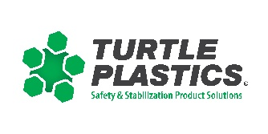

Billy Leach, Jr. Memorial
Training Grant

Turtle Plastics® offers up to $500.00 stipends to assist volunteer fire fighting personnel in good standing with their department to attend various training events throughout the United States. With the ever-increasing cost of travel and reduction in fire department budgets, we hope funds from the Billy Leach, Jr. Memorial Training Grant program will assist you in attending training of your choice.

To apply please include your name, department, chief or designee’s signature and a brief reason for your request. All applications will be reviewed, and stipends granted on an as needed basis as funding is available.

TRAINING PROGRAM REQUIRED
FDIC
Firehouse World
Training School/Institute: (Please specify): _______________________________________
Other (Please specify):_________________________________________________

REQUESTER’S INFORMATION (please complete all boxes)
DEPARTMENT/AGENCY NAME |  | STATION #
REQUESTER’S NAME | CHIEF/DESIGNEE
MAKE CHECK PAYABLE TO (MAY BE AN INDIVIDUAL)
MAILING ADDRESS FOR FUNDS
CITY | STATE | ZIP
PHONE | FAX | E-MAIL

BRIEF REASON FOR THIS REQUEST:

REQUIRED SIGNATURES
REQUESTER’S SIGNATURE: DATE:

CHIEF/DESIGNEE’S SIGNATURE: DATE: _

PLEASE SEND FORM TO:
Turtle Plastics®
7400 Industrial Parkway
Lorain, Ohio 44503
or
fax to: 1-800-437-1603
Please allow 4-6 weeks to process request.
You will be notified of grant request within 30 days of receipt of grant form. Grants are released on a first come, first serve basis during the calendar year.

