2022 Lift Bag Protection & Pad Kits 7400 Industrial Parkway Drive Lorain, OH 44053 (800) 756-6635 orders@turtleplastics.com
Photo | Kit Name |  | Mod Pad Lifting Kit A Small | Mod Pad Lifting Kit B Small | Mod Pad Lifting Kit C Small | Mod Pad Lifting Kit 10  Medium | Mod Pad Lifting Kit 28  Medium | Mod Pad Lifting Kit  10M  Top Bag Pad
 |  |  | Part # | Part # | Part # | Part # | Part # | Part #
 | Component | Description | MPLK | MPLK | MPLK | MPLK | MPLK | MPLK
 |  |  | A | B | C | 10M | 28M | 10MTBP
 | CTP1818- 1.5 | 18"x18"x11/2"  Mod Pad® w/Level | 2 | 2 | 2
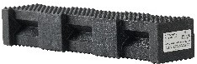 | 44PL-18 | 4”x4”x18”  Hybrid Crib® | 3 | 18 | 27
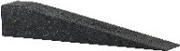 | 4/4-20 | 4”x4”x20”  Wedge | 2 | 2 | 2
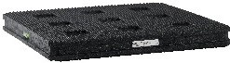 | CTP2424-2  W/L | 24"x24"x2"  Mod Pad  ®w/Level |  |  |  | 2 | 2 | 2
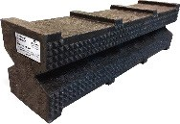 | 67SC-24 | 6”x7”x24”  Super Crib® |  |  |  | 3 | 12 | 6
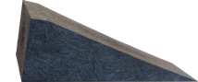 | 6/7-24 | 6”x7”x24”  Super Wedge |  |  |  | 2 | 2 | 2
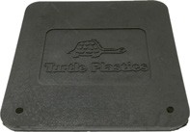 | TBP | Top Bag Pad |  |  |  |  |  | 1
 |  | Weight (in lbs.) | 59 | 149 | 203 | 162 | 391 | 250
***Are you conducting Fleet Maintenance? Please call us to inquire about our new Fleet Maintenance Starter Kit
that includes many of our most popular components with additional industrial cribbing to help stabilize
heavy equipment and/or apparatus during repairs. Reference Part #FMBS.

