2022 FEMA/USAR Kits 7400 Industrial Parkway Drive Lorain, OH 44053 (800) 756-6635 orders@turtleplastics.com
***Heavy Duty FEMA/USAR Kits can be created utilizing the Full Slabs, Half Slabs, Prime Cribs, and UMHW Protection Pads. Please call us to help you customize your kit.
Photo | Component | Description | Part # PMSCK | Part #  USAR KIT A-Gen 2 | Part # USAR KIT B-Gen 2
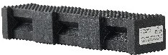  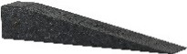  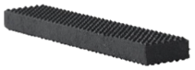  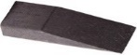  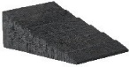  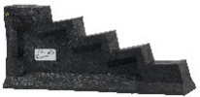  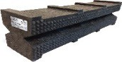  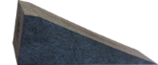  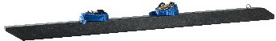  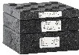  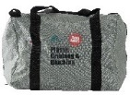  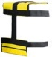 | 44PL-18 | 4”x4”x18”  Hybrid Crib® |  | 27 | 36
 | 4/4-20 | 4”x4”x20” Wedge |  | 12 | 12
 | 24-18 CRIB | 2”x4”x18”  Pyramid Crib® |  | 12 | 12
 | 2/4-12 | 2”x4”x12” Wedge |  | 12 | 12
 | 6W | 6” W x 81/2”  Long Wedge | 2
 | WC-2 | Pair of Wheel  Chocks |  | 1 | 2
 | SC-1 | Standard Step Chock | 2 |  | 4
 | CTP1818-1.5 | 18"x18"x11/2"  Mod Pad® w/Level |  |  | 2
 | 67SC-24 | 6”x7”x24”  Super Crib® |  |  | 9
 | 6/7-24 | 6”x7”x24”  Super Wedge |  |  | 2
 | 44-SCH-BLK | 4”x4”x6”  Shoring Crib | 2 |  | 2
 | LB-K | Lock Block/Blox® Kit 1B/2B/3B |  |  | 1
 | To include bags at an additional cost, use the following Part #: |  |  | USAR Kit A Gen 2B | USAR Kit B Gen 2B
 | CB | Carrying Bag |  | 1 Bag | 2 Bags
 | CT | Crib Toters |  | 3 Toters | 4 Toters
 |  | Weight (in lbs.) | 95 | 295 | 766
Get Your FREE Bonus Product When You Purchase USAR Kit A or USAR Kit B. When You Purchase any USAR Kit
you receive (1) Top Bag Pad valued at $127.85.

