2022 Crib Toter Kits 7400 Industrial Parkway Drive Lorain, OH 44053 (800) 756-6635 orders@turtleplastics.com
Photo  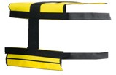  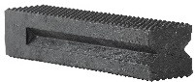  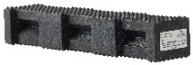 | Component | Description | Part # CT44-18 | Part # CT44PL-18
 | CT | Crib Toter Bag | 2 | 2
 | 44-18 CRIB | Pyramid Crib Toter Kit with 4”x4”x18” Pyramid Cribs | 18
 | 44PL-18 CRIB | Hybrid Crib Toter Kit with 4”x4”x18” Hybrid Crib |  | 18
 |  | Weight (in lbs.) | 119 | 110
2022 Basic Stabilization Tool Kits
Photo  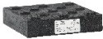  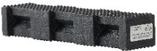  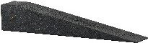  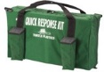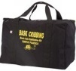 | Component | Description | Part # QR-2 | Part # SA-2 | Part # SA-4 | Part # BASK 1
 | SC-1 | Standard Step Chocks | 2 | 2 | 4
 | 3W | 3” W x 81/2” Long Wedge | 2 | 2 | 4
 | 1B | 1” Thick x 9” Sq.  Turtle Lock Block/Blox® | 2 | 2 | 4
 | 2B | 2” Thick x 9” Sq.  Turtle Lock Block/Blox® | 1
 | 44PL-18 | 4”x4”x18” Hybrid Crib® |  |  |  | 4
 | 4/4-20 | 4”x4”x20” Wedge |  |  |  | 4
 | WC-2 | Pair of Wheel Chocks | 1 |  |  | 1
 | QR-2 BAG | 25"x 15"x16" Carrying Bag | 1 | 1 | 2
 | BASK BAG | 24" x17"x16" Carrying Bag |  |  |  | 1
 |  | Weight (in lbs.) | 56 | 39 | 79 | 55
2022 Cog Step Chock Kits

Photo  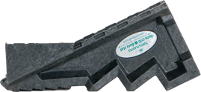  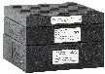 | Component | Description | Part #  COG Kit A
 | SC-COG-1 | COG Step Chock | 2
 | LB-K | Turtle Lock Block/Blox® Kit 1B/2B/3B | 4
 |  | Weight (in lbs.) | 104
Get Your FREE Bonus 2 Carrying Bags When You Purchase the Cog Step Chock Kit A valued at $97.80.

