Photo  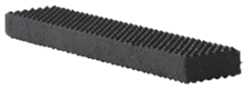  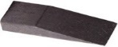  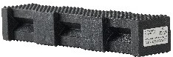  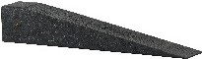  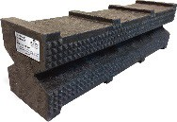  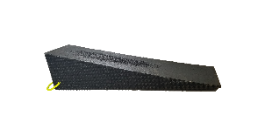  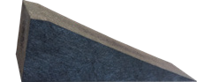  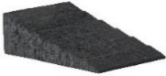  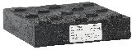  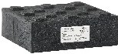  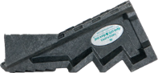 | Component | Description | Part # Auto X  Kit A | Part # Auto X  Kit B | Part # Auto X  Kit C | Part # Auto X  Kit D | Part # Auto X  Kit E
 | 24-18 CRIB | 2”x4”x18”  Pyramid Crib® | 6 | 12 | 12 | 12 | 24
 | 2/4-12 | 2”x4”x12” Wedge | 2 | 4 | 4 | 4 | 8
 | 44PL-18 | 4”x4”x18” Hybrid Crib® | 9 | 18 | 36 | 36 | 36
 | 4/4-20 | 4”x4”x20” Wedge | 2 | 2 | 8 | 8 | 4
 | 67SC-24 | 6”x7”x24” Super Crib® |  |  | 8 | 8 | 18
 | 6/7-24 | 6”x7”x24” Super Wedge |  |  | 2 | 4 | 4
 | 3W | 3” W x 81/2”  Long Wedge | 1 | 2 | 2 | 4 | 4
 | 6W | 6” W x 81/2”  Long Wedge | 1 | 2 | 2 | 4 | 4
 | 1B | 1” Thick x 9” Sq.  Turtle Lock Block/Blox® | 1 | 1 |  | 4 | 4
 | 2B | 2” Thick x 9” Sq.  Turtle Lock Block/Blox® | 1 | 1 |  | 4 | 4
 | 3B | 3” Thick x 9” Sq.  Turtle Lock Block/Blox® | 1 | 1 |  | 4 | 4
 | SC-1 | Standard Step Chock | 2 | 2 | 4 | 4 | 4
 | WC-2 | Pair of Wheel Chocks | 1 | 2 | 4 | 4 | 4
 | CTP1818-1.5 | 18"x18"x11/2"  Mod Pad® w/Level | 1 | 1 | 2 | 2 | 4
 | SC-COG-1 | Cog Step Chock |  |  |  | 2
To include bags at an additional cost, use the following Part #: |  |  | Auto X  Kit A-B | Auto X  Kit B-B | Auto X  Kit C-B | Auto X  Kit D-B | Auto X  Kit E-B
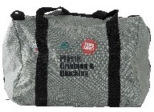  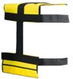 | CB | Carrying Bag | 1 Bag | 2 Bags | 4 Bags | 4 Bags | 4 Bags
 | CT | Crib Toter | 1 Toter | 2 Toters | 4 Toters | 4 Toters | 4 Toters
 |  | Weight in lbs. (includes  bonus) | 175 | 280 | 687 | 806 | 1073
Get Your FREE Bonus Product(s) When You Purchase Any Auto X Crib Tool Kit(s) . When You Purchase an Auto X Tool Kit A you receive (1) Top Bag Pad valued at $127.85. When You Purchase an Auto X Tool Kit B, C, D or E you receive (2) Top Bag Pads valued at $255.70.
2022 Engine/Rescue Equipment Kits 7400 Industrial Parkway Drive Lorain, OH 44053 (800) 756-6635 orders@turtleplastics.com

