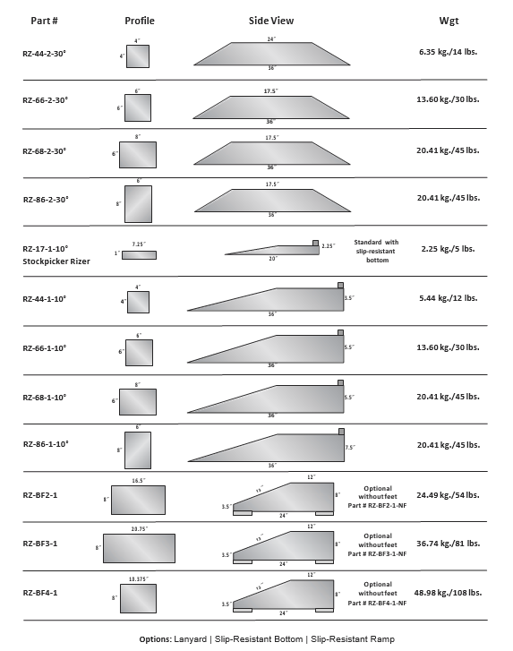

## Turtle Plastics’ Rizers