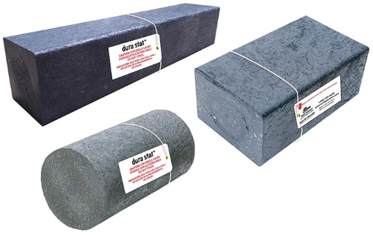
Dura Stat brand of engineered, recycled plastic blocking have a smooth façade and are the durable alternative to wood in applications such as material storage both indoor or outdoor as well as for marine shoring. Dura Stat blocks are created for single layer application and when load bearing is static (item on block is not being moved due to use of pneumatic or hydraulic tools for example). For this reason, we do not recommend Dura Stat blocks for any cribbing applications. Please use Dura Crib brand blocking products instead.
- Part #: see chart below.
- Smooth profile on all four sides.
- Multiple lengths available ranging from 2’ to 12’.
- Replaces metal framing and wood timbers for storing raw materials.
- Creosote-free and superior performance to railroad timber.
- Ideal alternative to wood on tractor trailers during material transportation (dunnage).
- Washable; won’t rot, split, or absorb moisture.

Part # | Description | Application | Dimensions | Wt. Each
DSSQ226 | Square Blocks | Storage | 2"x2"x6' | 2.72 kg/6 lbs.
DSSQ2212 | Square Blocks | Storage | 2"x2"x12' | 5.44 kg/12 lbs.
DSSQ3312 | Square Blocks | Storage | 3"x3"x12' | 13.15 kg/29 lbs.
DSSQ446 | Square Blocks | Storage | 4"x4"x6' | 14.06 kg/31 lbs.
DSSQ4412 | Square Blocks | Storage | 4"x4"x12' | 27.66 kg/61 lbs.
DSSQ668 | Square Blocks | Storage | 6"x6"x8' | 35.83 kg/79 lbs.
DS236 | Rectangular Blocks | Storage | 2"x3"x6' | 4.53 kg/10 lbs.
DS2312 | Rectangular Blocks | Storage | 2"x3"x12' | 8.61 kg/19 lbs.
DS246 | Rectangular Blocks | Storage | 2"x4"x6' | 5.89 kg/13 lbs.
DS248 | Rectangular Blocks | Storage | 2"x4"x8' | 8.16 kg/18 lbs.
DS2412 | Rectangular Blocks | Storage | 2"x4"x12' | 11.79 kg/26 lbs.
DS266 | Rectangular Blocks | Storage | 2"x6"x6' | 9.07 kg/20 lbs.
DS268 | Rectangular Blocks | Storage | 2"x6"x8' | 11.79 kg/26 lbs.
DS2612 | Rectangular Blocks | Storage | 2"x6"x12' | 17.69 kg/39 lbs.
DS286 | Rectangular Blocks | Storage | 2"x8"x6' | 11.79 kg/26 lbs.
DS288 | Rectangular Blocks | Storage | 2"x8"x8' | 15.42 kg/34 lbs.
DS2812 | Rectangular Blocks | Storage | 2"x8"x12' | 23.13 kg/51 lbs.
DS2106 | Rectangular Blocks | Storage | 2"x10"x6' | 16.32 kg/36 lbs.
DS2108 | Rectangular Blocks | Storage | 2"x10"x8' | 21.11 kg/48 lbs.
DS21012 | Rectangular Blocks | Storage | 2"x10"x12' | 32.65 kg/72 lbs.
DS346 | Rectangular Blocks | Storage | 3"x4"x6' | 9.63 kg/21 lbs.
DS348 | Rectangular Blocks | Storage | 3"x4"x8' | 12.70 kg/28 lbs.
DS3412 | Rectangular Blocks | Storage | 3"x4"x12' | 19.05 kg/42 lbs.
DS3106 | Rectangular Blocks | Storage | 3"x10"x6' | 26.30 kg/58 lbs.
DS3108 | Rectangular Blocks | Storage | 3"x10"x8' | 34.93 kg/77 lbs.
DS31012 | Rectangular Blocks | Storage | 3"x10"x12' | 52.16 kg/115 lbs.
DS4612 | Rectangular Blocks | Storage | 4"x6"x12' | 35.83 kg/79 lbs.
DS688 | Rectangular Blocks | Storage | 6"x8"x8' | 49.89 kg/110 lbs.
DFM66/310-96 | Dura Frame Master 66/310/96-Two pieces 6"x6"x96" Dura Stat stacked and bolted to one piece Dura Stat 3"x10"x96" (for storage) – size can be customized to your specifications.

