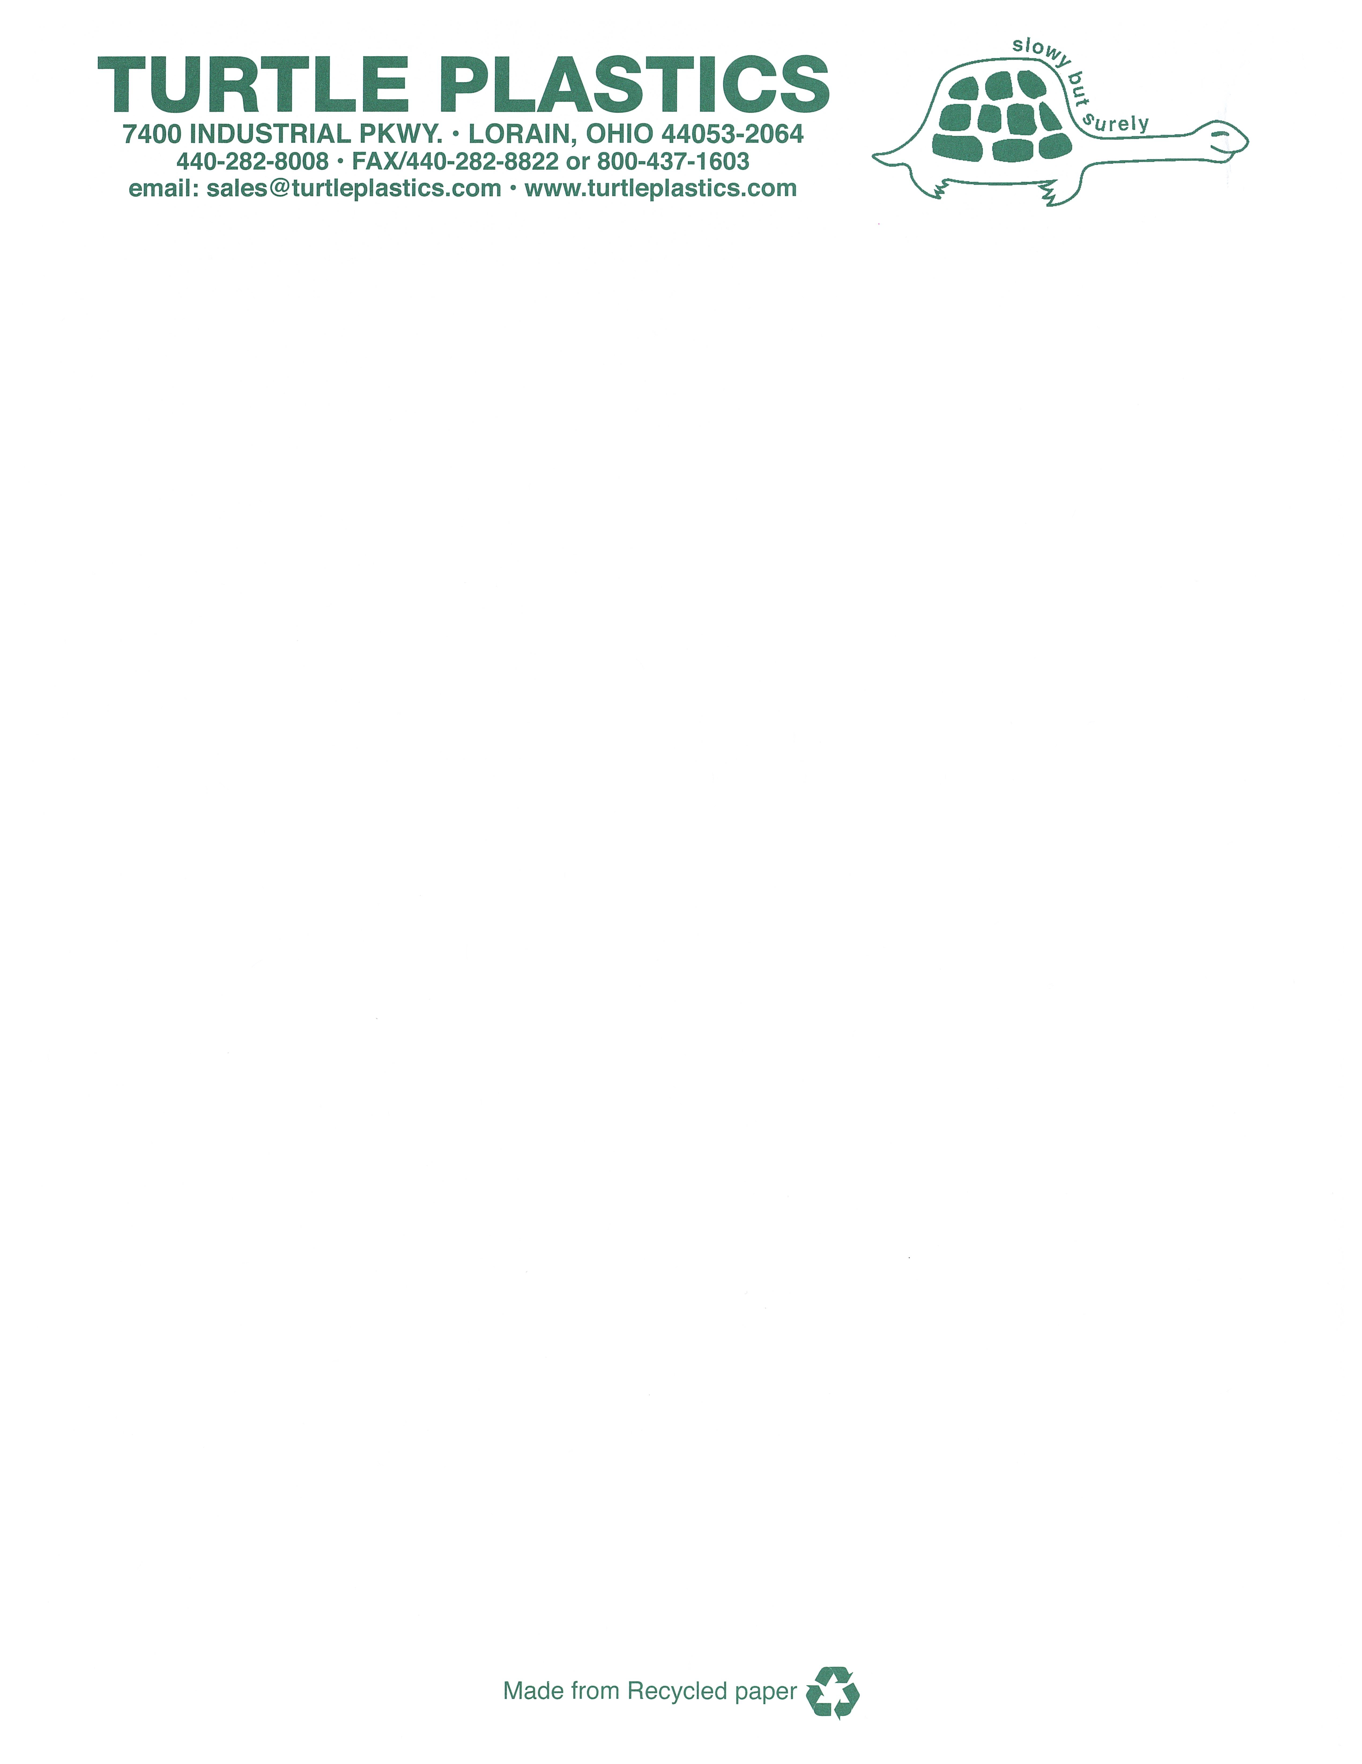

**Turtle Plastics Limited Warranty**

**Dura Crib Products**

**As of December 1, 2018**

1. Cleveland Reclaim Industries Inc. dba Turtle Plastics (hereinafter “Company”) warrants to the original purchaser at retail of its Published Products (hereinafter “Product”) that:
   1. For five (5) years from the date of the original purchase at retail, Company will provide a replacement Product for any Product that breaks for any reason other than obvious abuse or damage due to misapplication or improper installation.
   2. For ten (10) years from the date of the original purchase at retail, Company will provide a replacement on any Product that is sagging for any reason other than damage due to misapplication or improper installation.
   3. For fifty (50) years from the date of the original purchase at retail, Company will provide a replacement Product for any Product that becomes defective as a result of rot, termite infestation or corrosion.
   4. A Product shall be deemed broken or defective when it lacks the capacity to perform the primary function for which it was manufactured.
2. TO OBTAIN PERFORMANCE UNDER THIS WARRANTY, the original purchaser at retail must the original purchaser at retail must call the Turtle Plastics corporate office listed above to obtain a Return Goods Authorization number. Once a number has been generated, please return the broken or defective Product to Company postage paid, with a copy of the invoice documenting the date of purchase. Any Product returned for replacement under this warranty must be clearly marked with a “warranty return authorization code”, which the original purchase at retail may obtain from Company. Company will ship a replacement Product to the original purchaser at retail, postage due, within ten (10) days or as soon product become available of receiving the broken or defective Product. Company reserves the right to challenge any warranty claim for failures resulting from obvious abuse or damage due to misapplication or improper installation.
3. ANY EXPRESS WARRANTY NOT PROVIDED HEREIN, AND ANY REMEDY FOR BREACH OF CONTRACT WHICH BUT FOR THIS PROVISION MIGHT ARISE BY IMPLICATION OF OPERATION OF LAW, IS HEREBY EXCLUDED AND DISCLAIMED. THIS SALE IS MADE ON THE EXPRESS UNDERSTANDING THAT THERE IS NO IMPLIED WARRANTY THAT ANY PRODUCT SHALL BE FIT FOR ANY PARTICULAR PURPOSE OR AN IMPLIED WARRANTY THAT ANY GOODS SHALL BE MERCHANTABLE. THE ORIGINAL PURCHASER AT RETAIL ACKNOWLEDGES THAT SAID PURCHASER IS NOT RELYING ON COMPANY’S SKILL AND JUDGEMENT TO SELECT OR FURNISH GOODS SUITABLE FOR ANY PARTICULAR USE.
4. UNDER NO CIRCUMSTANCES SHALL COMPANY BE LIABLE TO THE ORIGINAL PURCHASER AT RETAIL OR ANY OTHER PERSON FOR ANY SPECIAL OR CONSEQUENTIAL DAMAGES, WHETHER ARISING OUT OF BREACH OF WARRANTY, BREACH OF CONTRACT, OR OTHERWISE. COMPANY SHALL IN NO EVENT BE LIABLE FOR ANY BREACH OF WARRANTY IN AN AMOUNT EXCEEDING THE PURCHASE PRICE OF ANY PRODUCT.
5. COMPANY SHALL IN NO EVENT BE BOUND BY ANY STATEMENT OR REPRESENTATION AS TO THE QUALITY OR PERFORMANCE OF ANY PRODUCT, OTHER THAN AS CONTAINED IN THIS WARRANTY.

**UMHW and Dura Stat Smooth Profile Products**

1. Cleveland Reclaim Industries Inc. dba Turtle Plastics (hereinafter “Company”) warrants to the original purchaser at retail of its Published Products (hereinafter “Product”) that:
   1. For one (1) year from the date of the original purchase at retail, Company will provide a replacement Product for any standard UMHW or Dura Stat Smooth Profile Product that breaks for any reason other than obvious abuse or damage due to misapplication or improper installation.
   2. A Product shall be deemed broken or defective when it lacks the capacity to perform the primary function for which it was manufactured.
   3. As in Items 2-5 above of the Dura Crib warranty provisions.